**Login Test Cases For Online Shopping Websites**

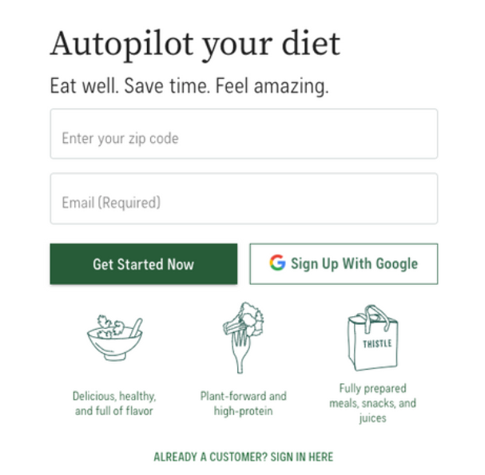

* Verify successful login with valid credentials.
* Test login with an incorrect password.
* Check login with an incorrect username/email.
* Test login with a locked or suspended account.
* Verify the "Forgot Password" link functionality.
* Test login using social media account credentials.
* Check for case sensitivity in usernames and passwords.
* Verify the session timeout behavior.
* Test login with special characters in the password.
* Test login with a blank username and password fields.
* Ensure the "Remember Me" functionality works as expected.
* Test the "Logout" functionality.
* Check for security measures like CAPTCHA during login.
* Test login on multiple devices and browsers.
* Verify that login attempts are logged for security monitoring.
* Test login with two-factor authentication (if supported).
* Verify login with biometric authentication (e.g., fingerprint, face ID).
* Test login using a one-time password (OTP).
* Verify login with a security token or smart card (if supported).
* Test login using a hardware security key (e.g., YubiKey).

### ****Test Cases For Registration Page On Ecommerce Websites****

* Verify successful user registration with valid information.
* Test registration with missing required fields (e.g., email, password).
* Check for proper error messages when registration fails.
* Test registration with a pre-existing email or username.
* Verify password strength validation during registration.
* Test registration using special characters in the name and address fields.
* Check if registration data is stored securely.
* Test registration using different browsers.
* Verify that registration confirmation emails are sent.
* Test the redirection after successful registration.

### ****Product Catalog Test Cases****

* Verify that all product categories are listed.
* Test filtering products by category.
* Verify that product images are displayed correctly.
* Test the accuracy of product descriptions.
* Verify that prices are correctly displayed.
* Test sorting products by price.
* Check for product availability indicators.
* Test the "New Arrivals" section for accuracy.
* Verify that product ratings are displayed.
* Test the product comparison feature.
* Check for related product recommendations.
* Test the "Quick View" feature for product details.
* Verify that the catalog page loads within an acceptable time.
* Test the responsiveness of the catalog page.
* Check for accessibility of product information for screen readers.

### ****Shopping Cart Test Cases****

* Test adding a product to the shopping cart.
* Verify that the cart icon updates with the item count.
* Test removing a product from the cart.
* Verify that the cart total is correctly calculated.
* Test updating the quantity of items in the cart.
* Check for proper validation of quantity input.
* Verify that discounts and coupons are applied correctly.
* Test the "Continue Shopping" button in the cart.
* Verify that the "Proceed to Checkout" button works.
* Test cart persistence across user sessions.
* Check for a confirmation message after adding/removing items.
* Test cart functionality with both registered and guest users.
* Verify that the cart is emptied after the order is placed.
* Test cart interactions on mobile devices.
* Check for security measures to prevent cart manipulation.

### ****Test Cases For The Checkout Process****

* Verify that the checkout process starts from the cart.
* Test selecting a shipping address during checkout.
* Verify that users can add/edit shipping addresses.
* Test selecting a payment method.
* Verify that users can add/edit payment methods.
* Test the application of discounts and coupons.
* Verify the order summary and item details on the checkout page.
* Test the "Place Order" button functionality.
* Verify the display of order confirmation details.
* Test the "Continue Shopping" option after checkout.
* Verify that taxes and shipping costs are accurately calculated.
* Test the ability to review and edit the order before placing it.
* Verify that the checkout process remains secure.
* Test the responsiveness of the checkout page.
* Check for accessibility of checkout steps for users with disabilities.
* Test payment processing using valid credit card details.
* Verify that the payment gateway processes transactions successfully.
* Test payment processing with an invalid credit card number.
* Verify the handling of declined payments.
* Test payment using alternative methods (e.g., PayPal, Apple Pay).
* Verify that payment confirmation emails are sent.
* Test payment processing with international currencies.
* Verify that the billing address matches the payment details.
* Test payment processing while changing the payment method.
* Verify the behavior of the payment gateway during high traffic.
* Test payment processing on mobile devices.
* Check for security measures like CVV validation.
* Test the cancellation of payment during the checkout process.
* Verify that users receive payment receipts.
* Test payment processing on different browsers.
* Verify the encryption of payment data for security.

# **Usability Testing**

* Can visitors find the information they need?
* Can visitors easily find your products?
* Can visitors make an informed purchase decision?
* Is the user interface smooth, and the process fast and easy?
* Which errors occur for the users?

# **Smoke Testing**

* Create a user profile
* Select an item
* Add to cart
* Check out

# **Ui Testing**

* Data type errors
* Field widths
* Navigational elements
* Progress bars
* Type-ahead
* Table scrolling
* Error Logging
* Menu Items
* Working shortcuts
* Example

 log in> add items to cart > view cart > make payment > enter delivery address > buy now